Azure Assignment

By – Ahmed Taufique

Emp Id – 1433732

1. Host a simple node-js application using custom data (linux)

A.

**Step-1:** Create a resource group

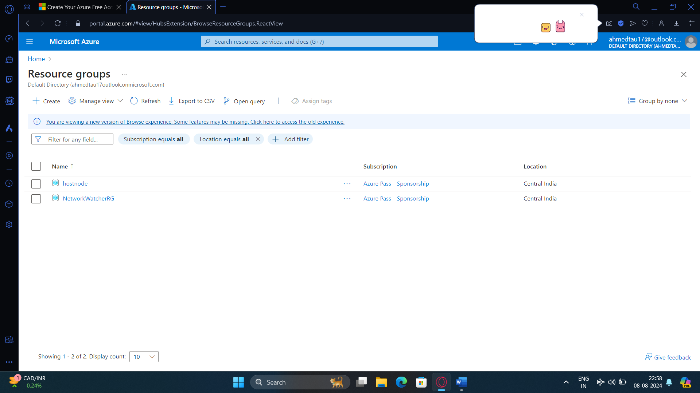

**Step-2:** Create a ubuntu virtual machine inside the created resource group

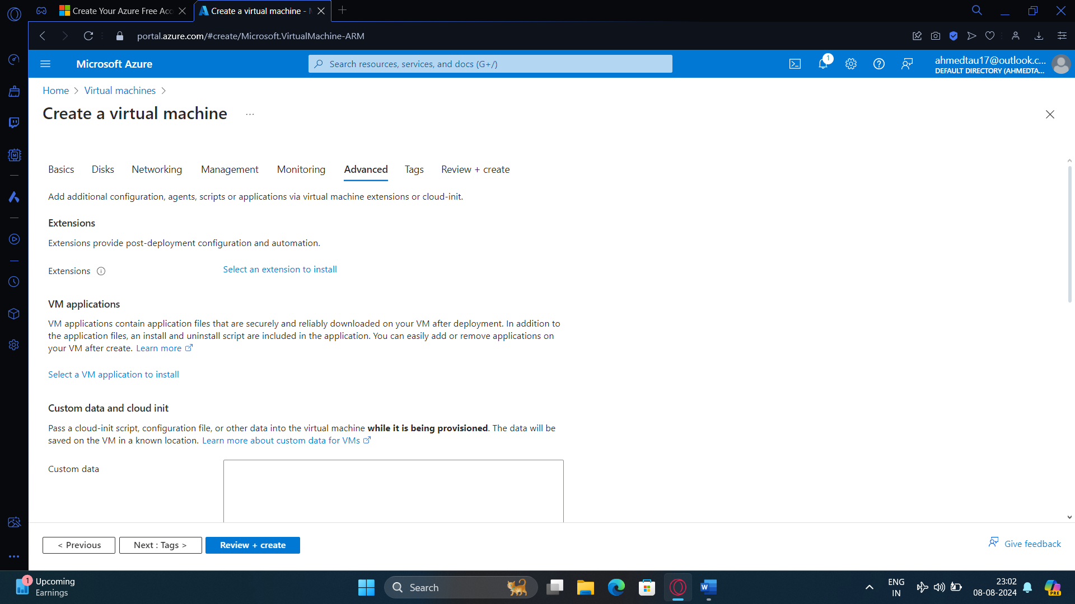

Step-3: Add the YAML script to install node-js into ubuntu (This will not install index.js we will have to install it later)

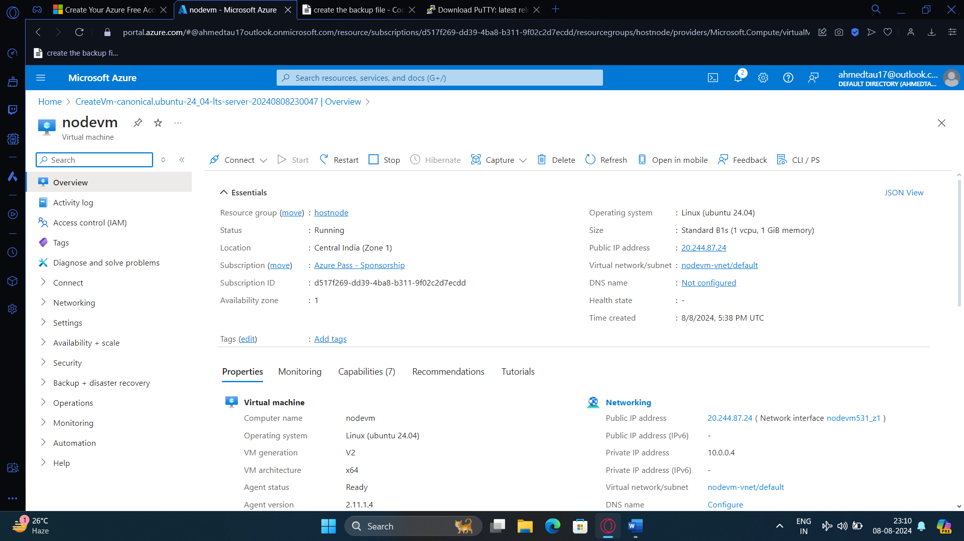

Step -4 : Login to the vm using putty and install the index.js manually, before creating make sure that HTTP and ssh are enabled

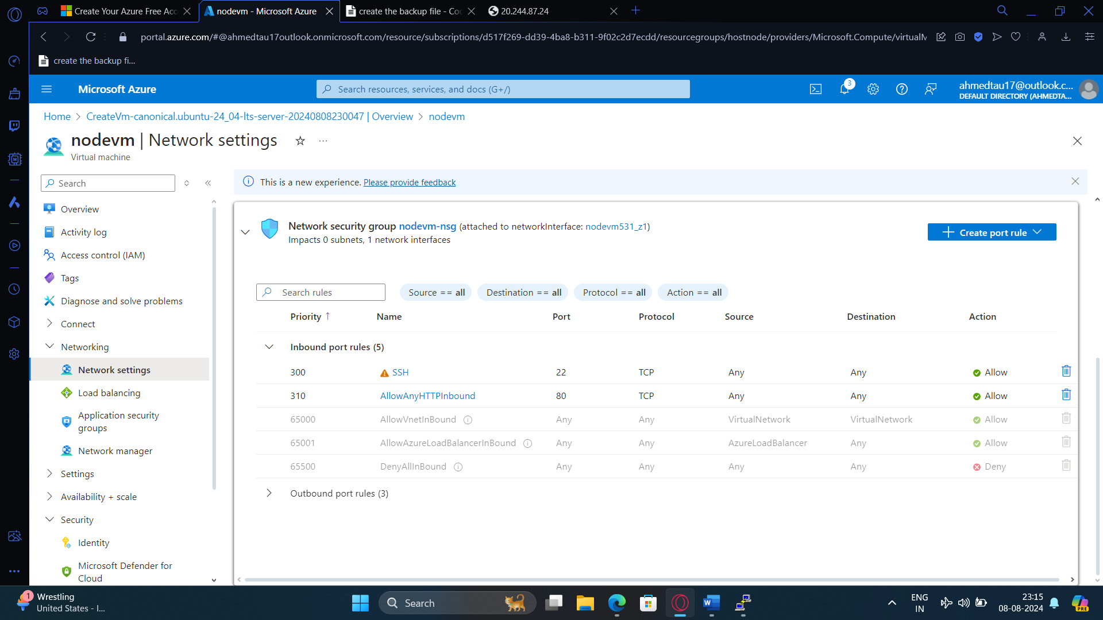

Step -5 : Run the index-js commands and let it install, after completion copy the ip address and paste it at the address bar

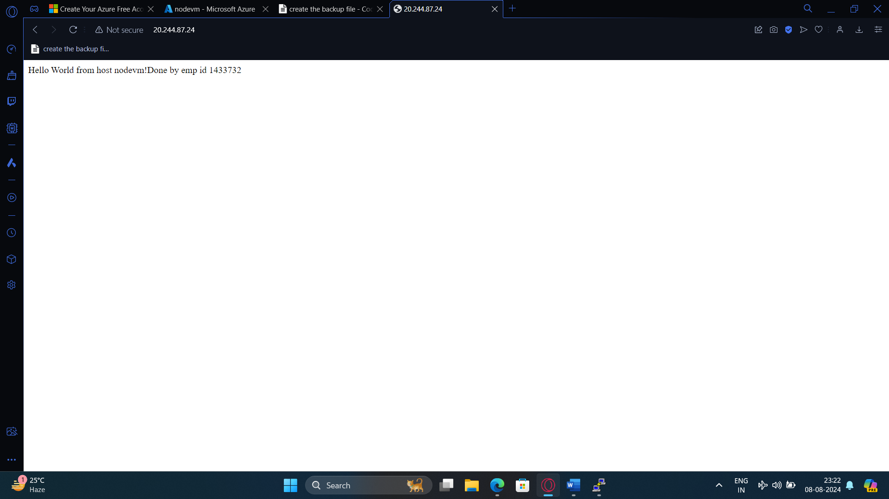

Code:

var express = require('express')

var app = express()

var os = require('os');

app.get('/', function (req, res) {

res.send('Hello World from host ' + os.hostname() + '!'+ 'Done by emp id 1433732' )

})

app.listen(3000, function () {

console.log('Hello world app listening on port 3000!')

})

2. Create a windows image with iis preinstalled (windows)

A. Step – 1 : Create a new resource group

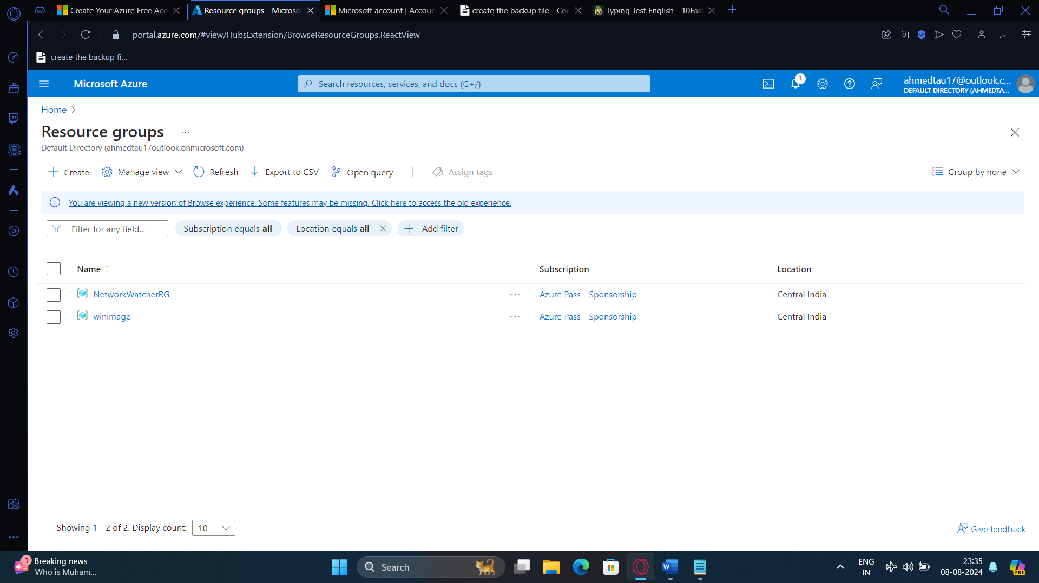

Step -2 : Install a vm with windows server 2022 and select the machine as d2s – v3

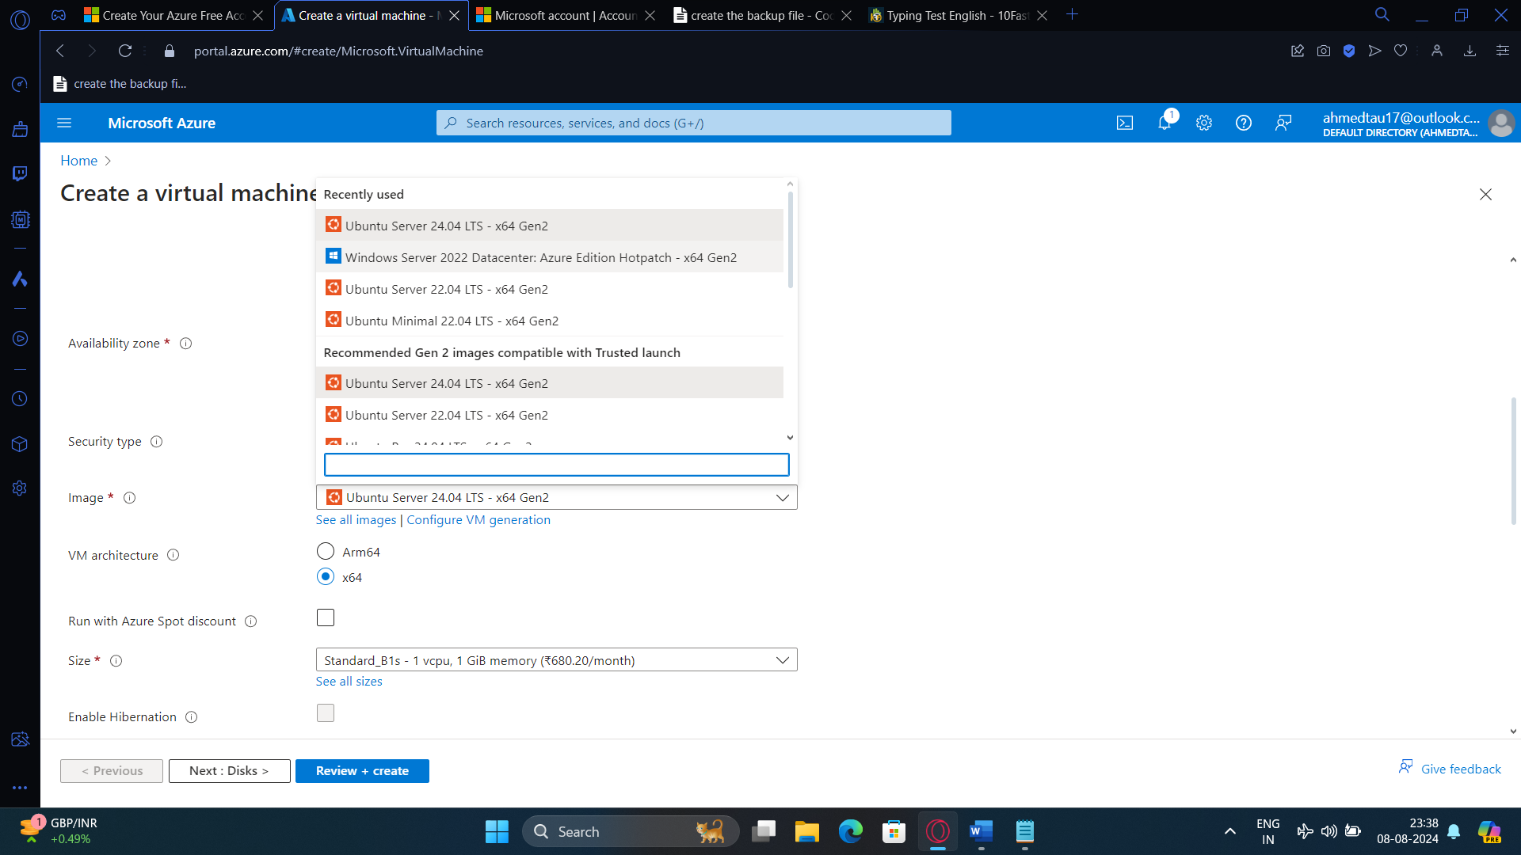

Step-3 Enable rdp and http ports

Step-4 : Copy the ip address of the machine and Connect to the machine using remote desktop from windows

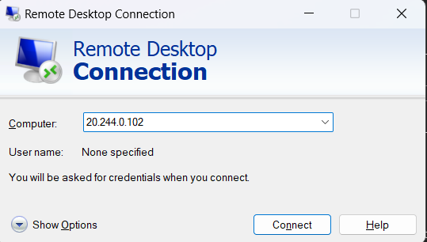

Step-5: Login and go to control panel and enable web server iis and type localhost in the address bar of the browser

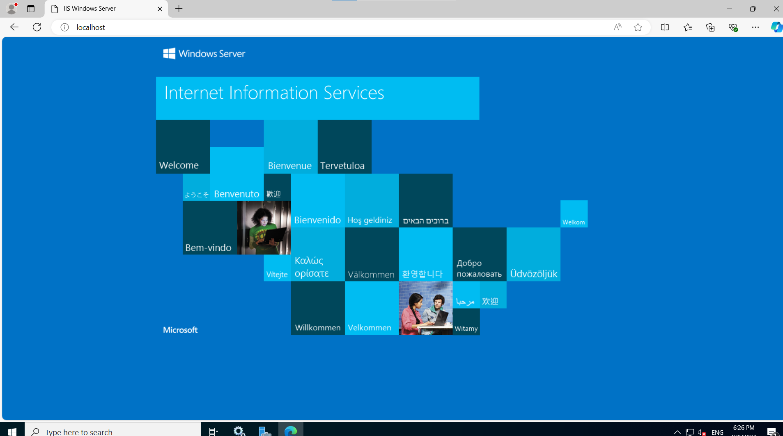

**Step-6 :** Now create the image of the virtual machine by clicking capture

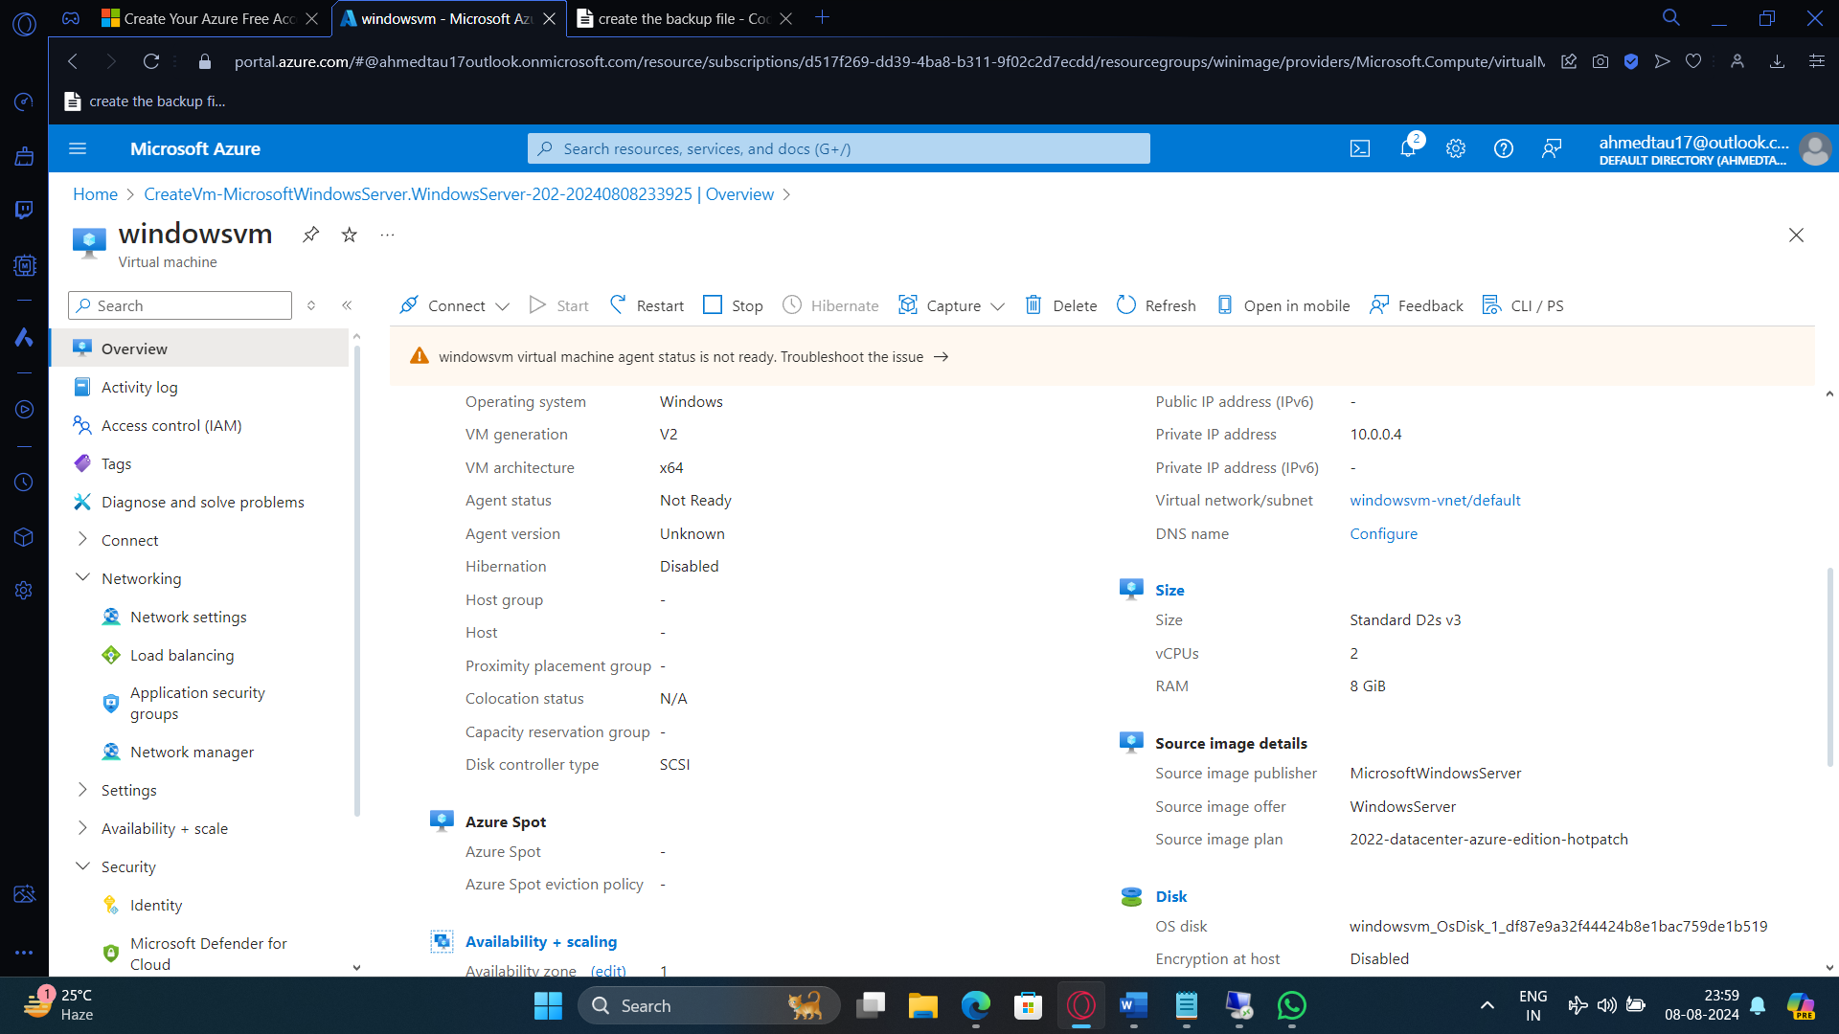

Step-7 : Create a new gallery

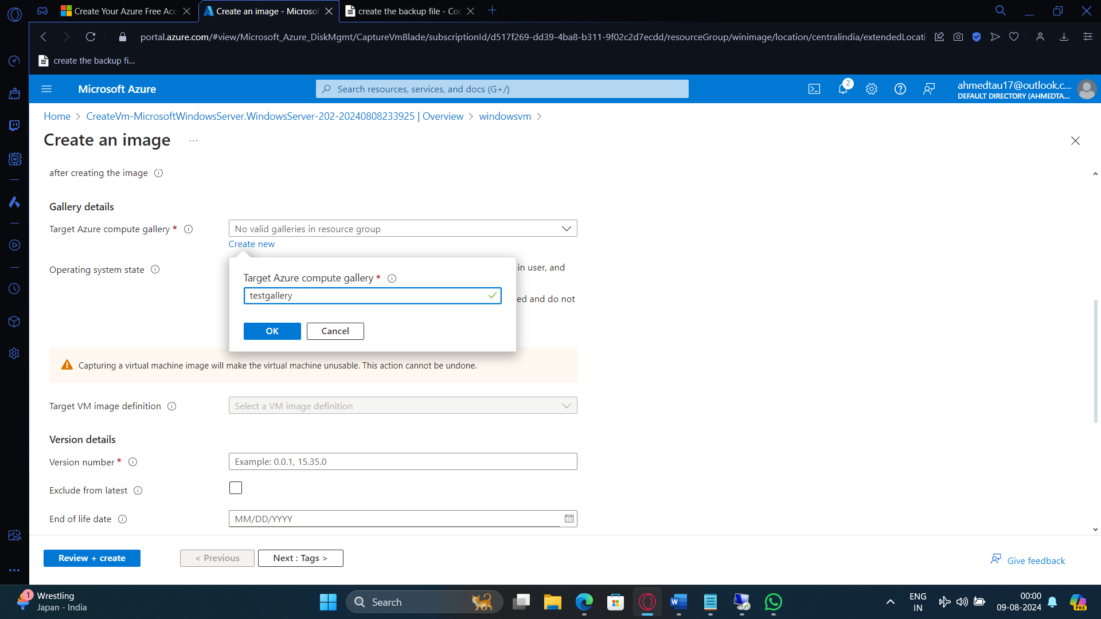

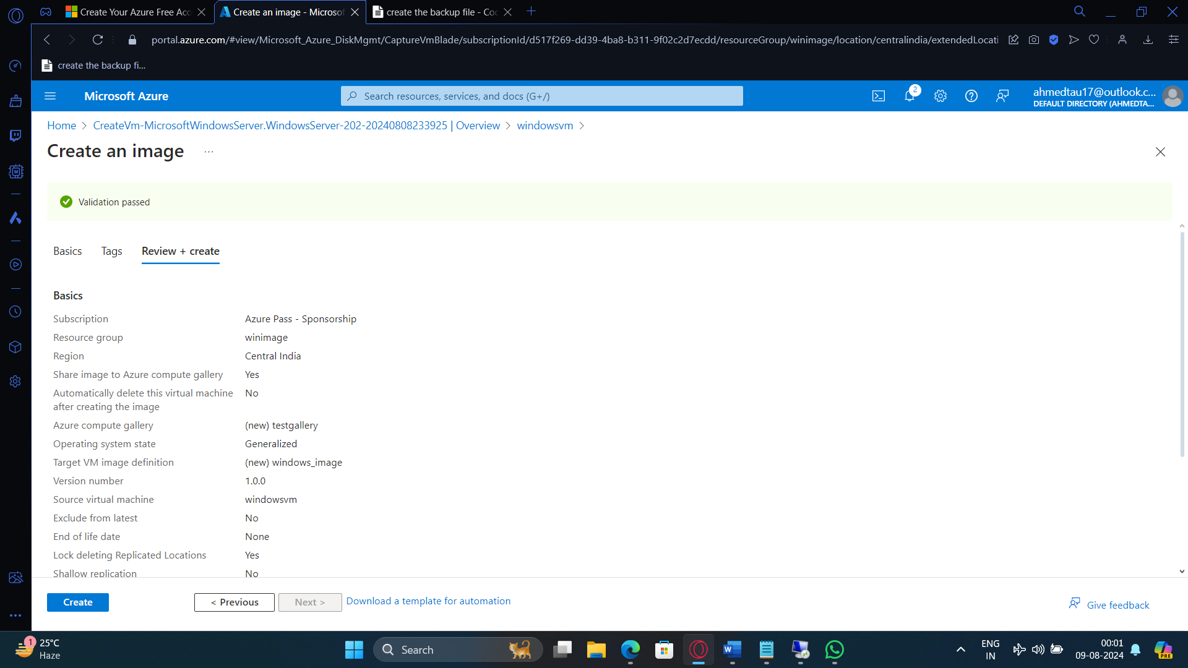

Step- 8 : Create another vm using this pre loaded image

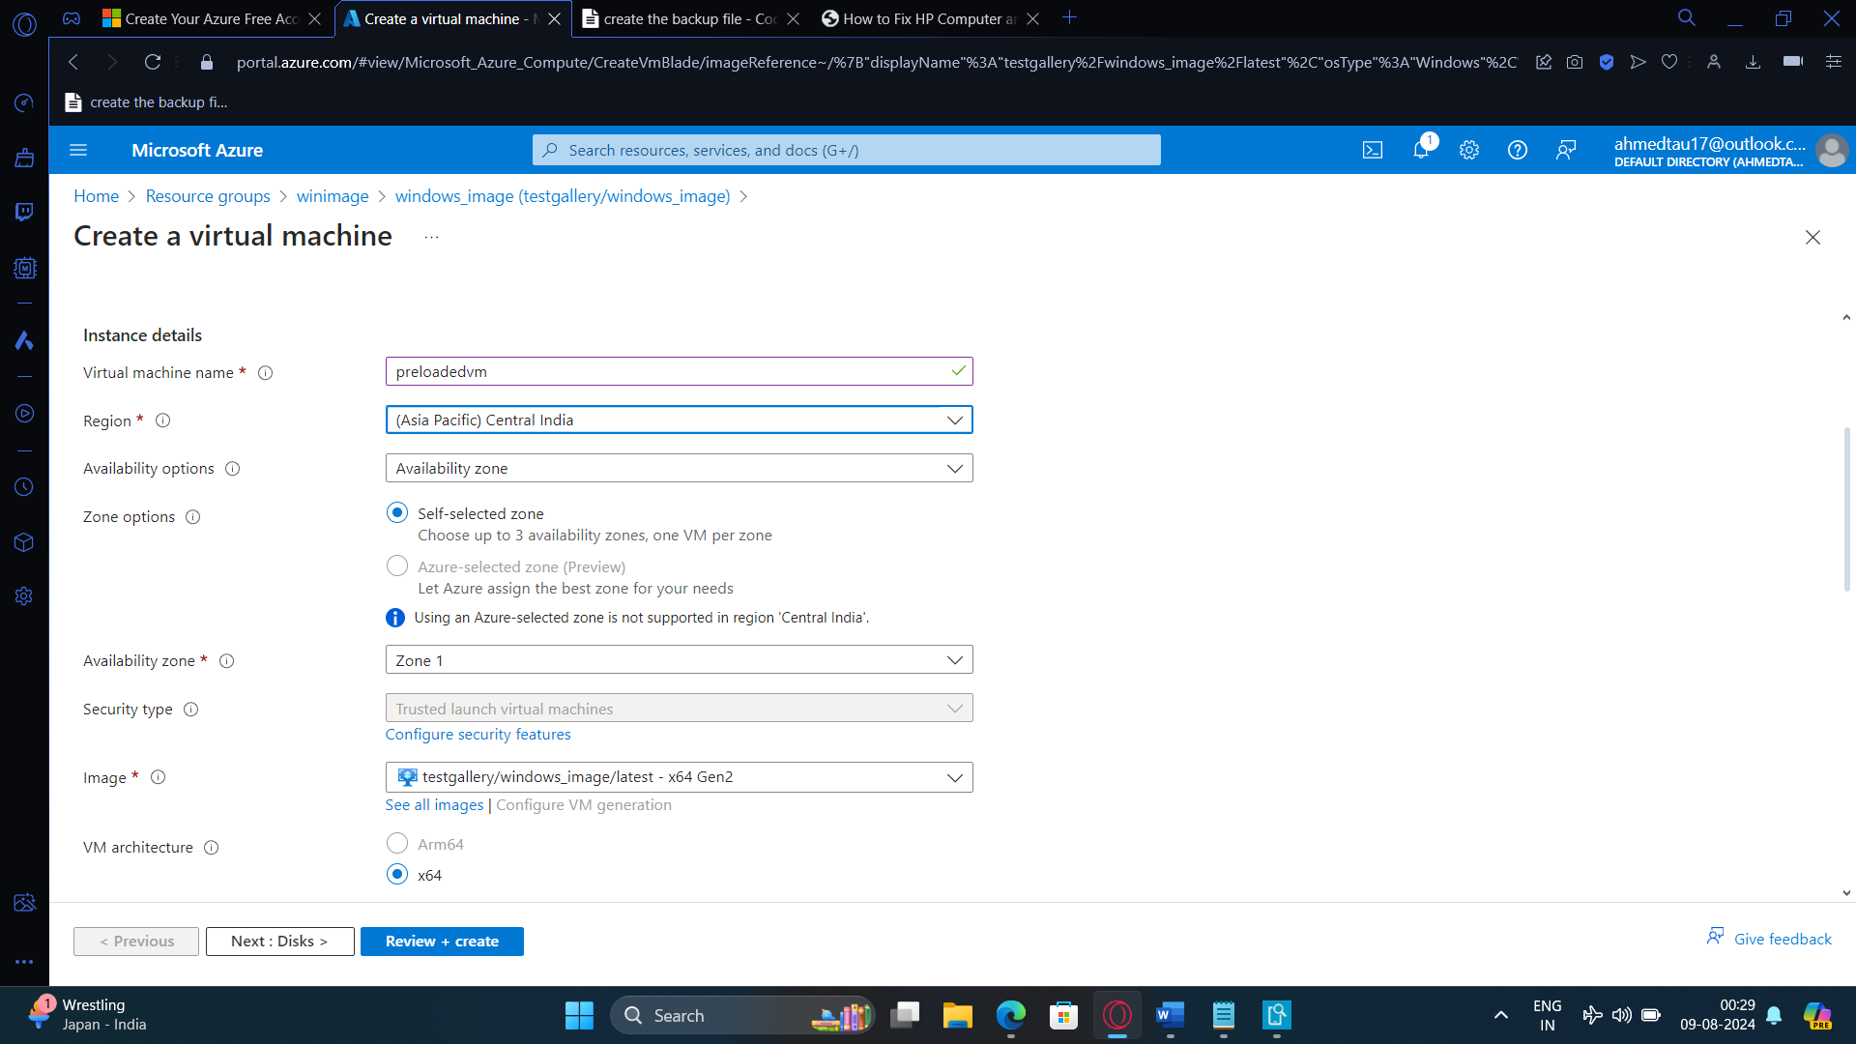

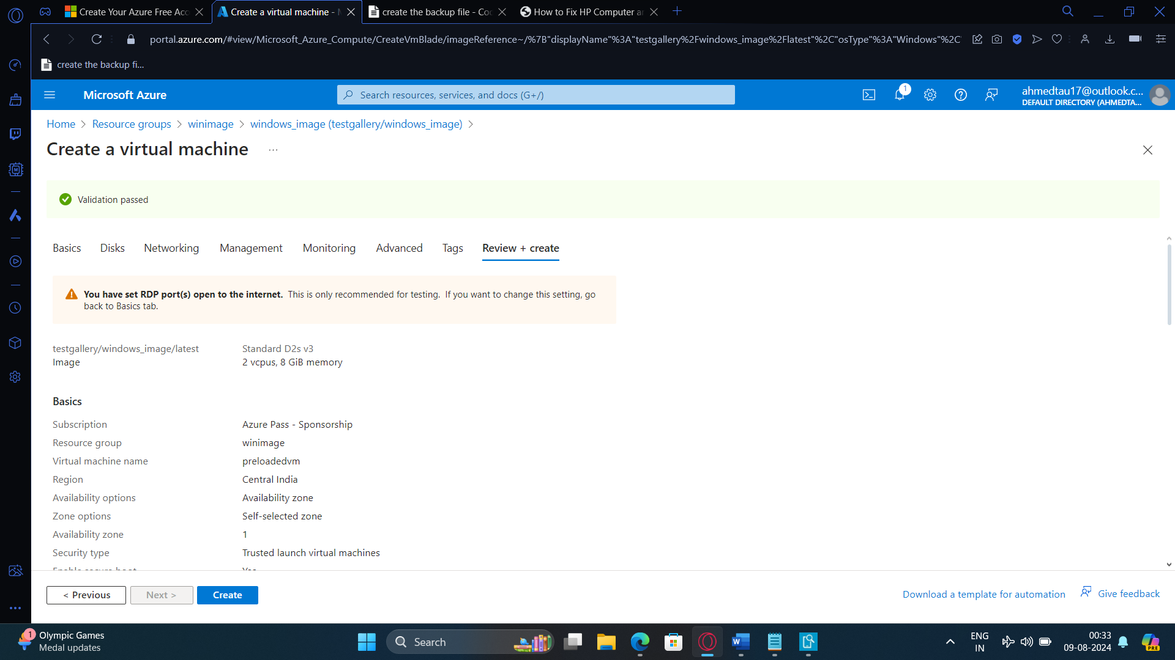

Step -9 : Check weather iis is present in this vm or not

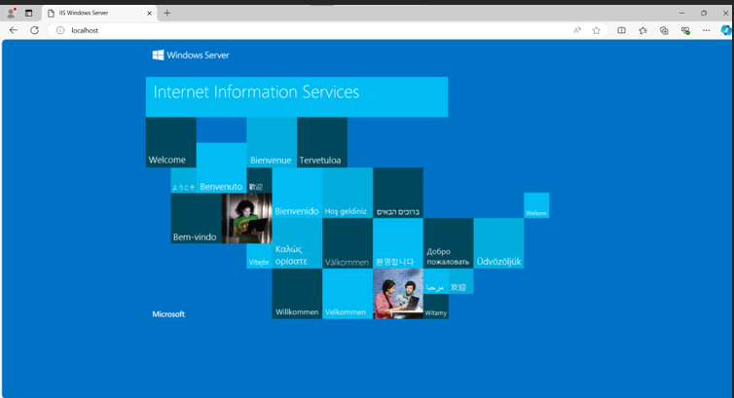

3. Bring a windows vm using azure cli

A.

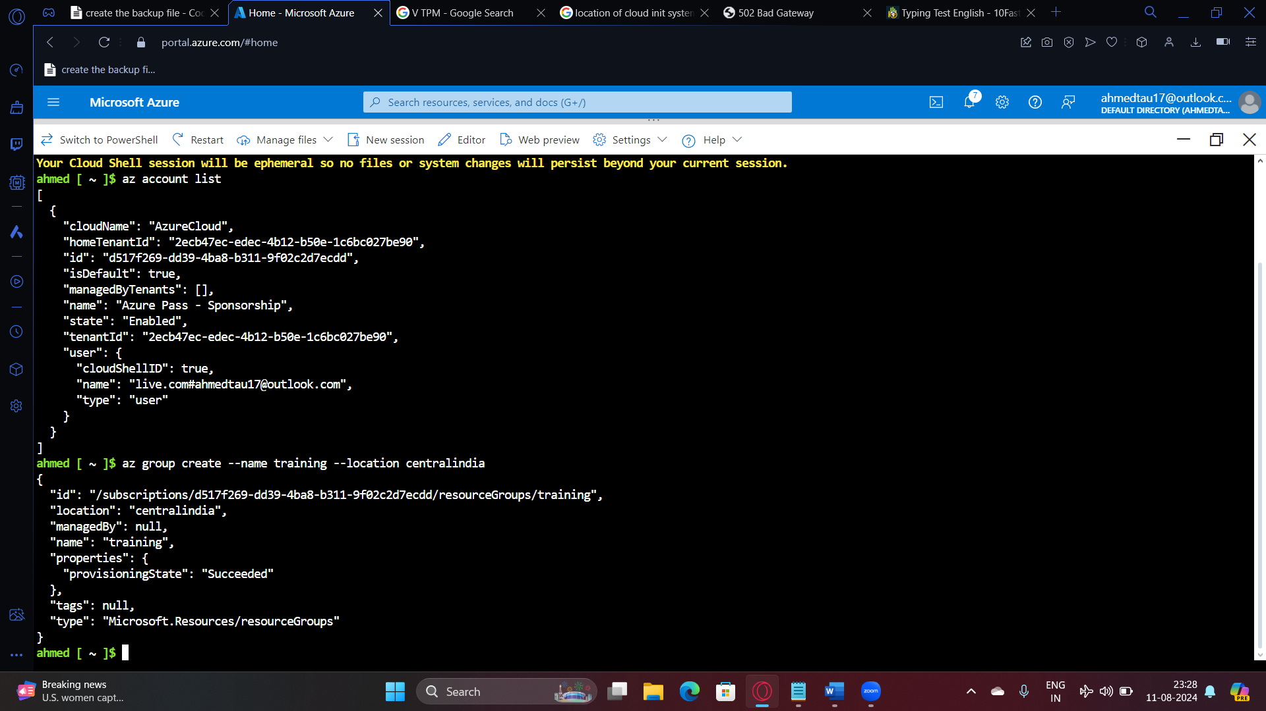

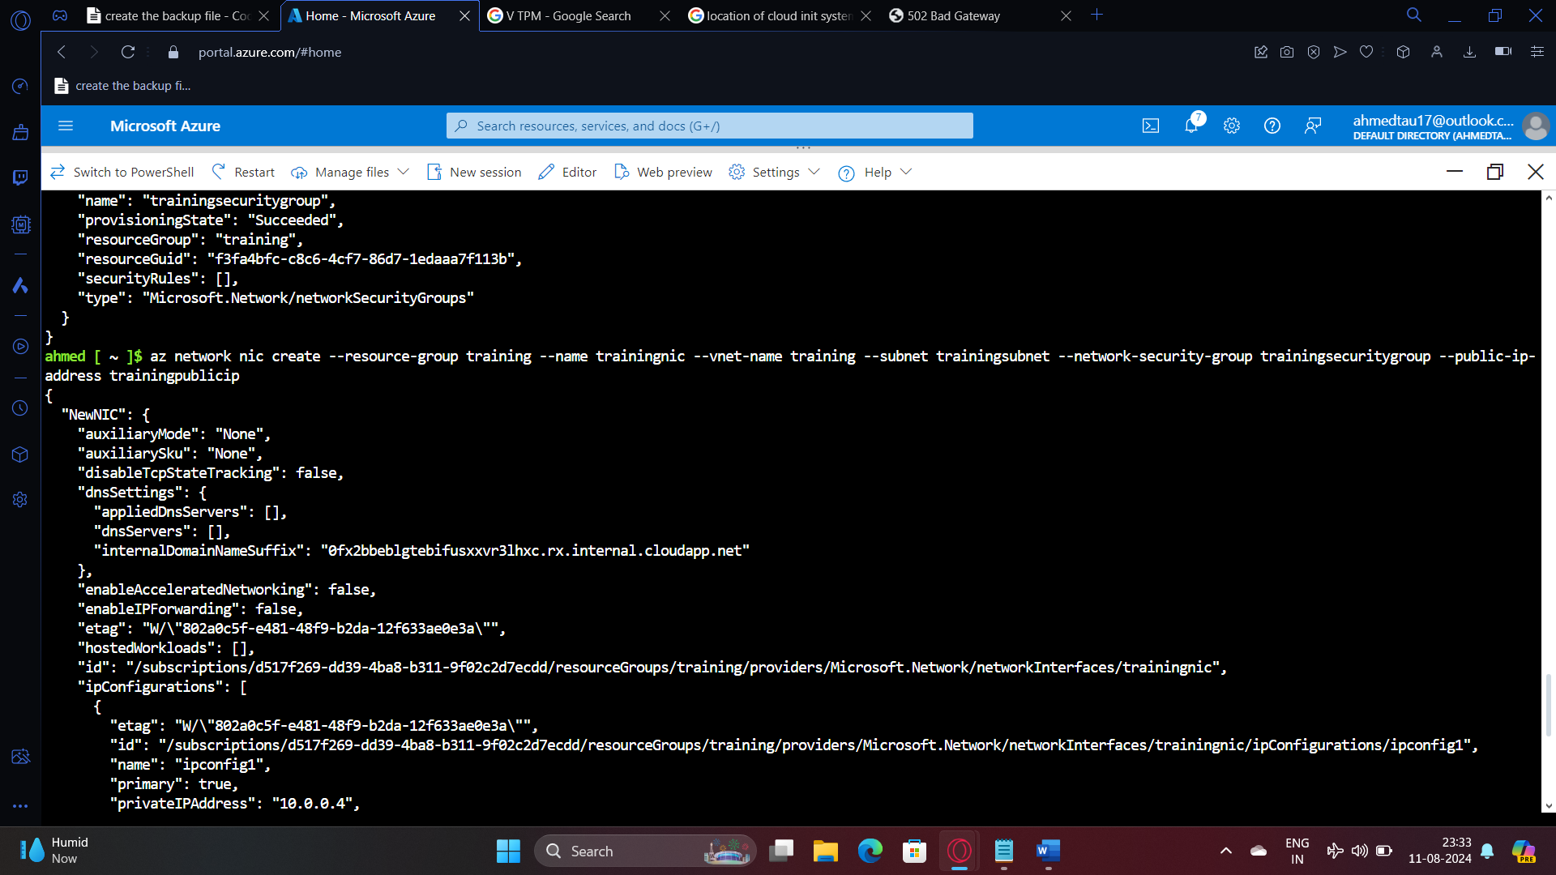

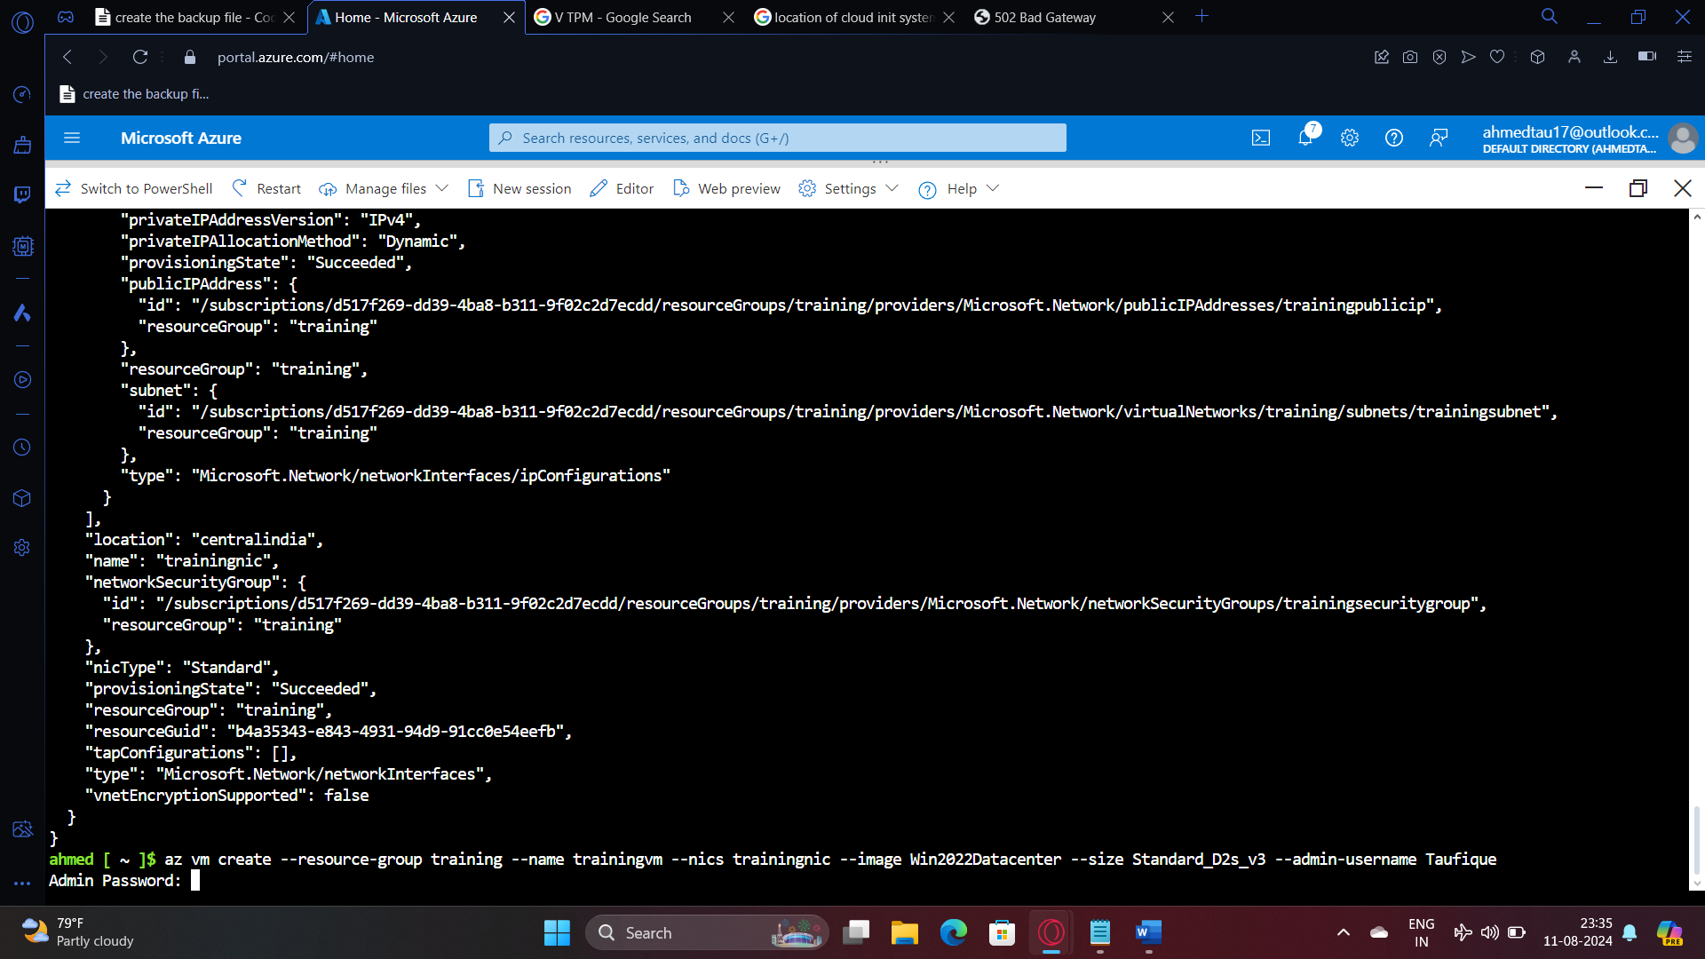

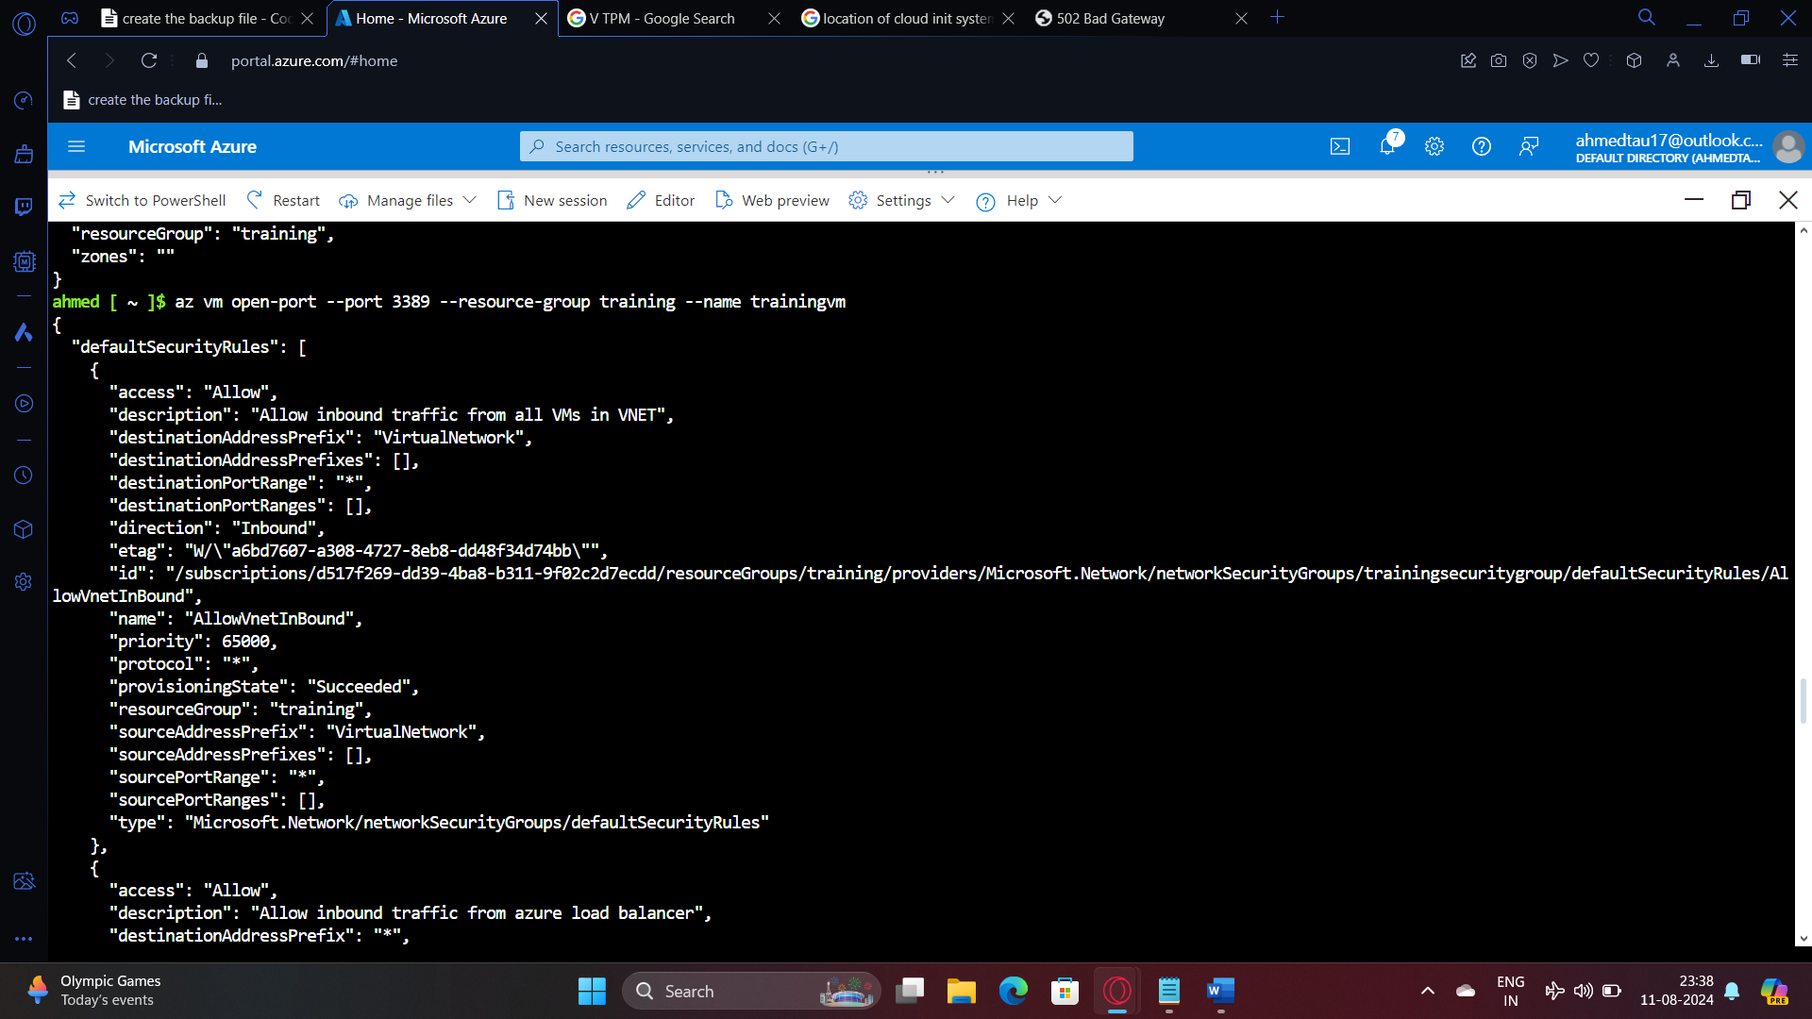

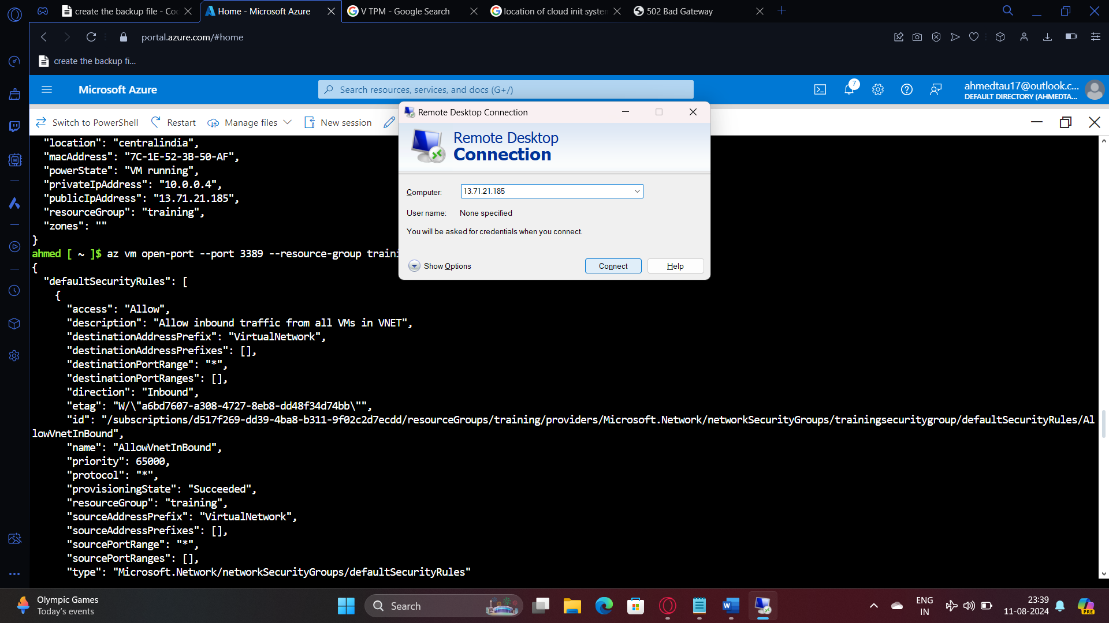

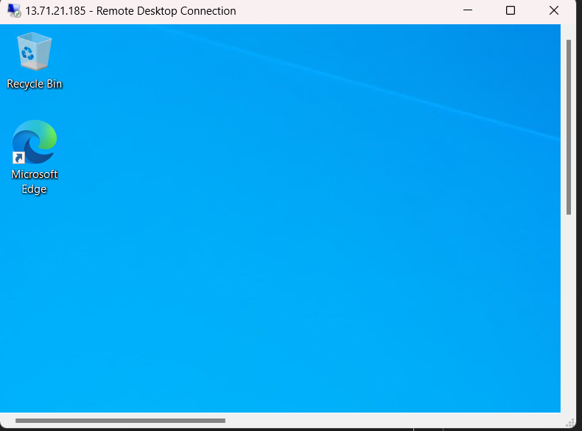

4. Create a vmscale set for windows os where if the average cpu utilization is greater than 50 it should scale up and scale down

A. 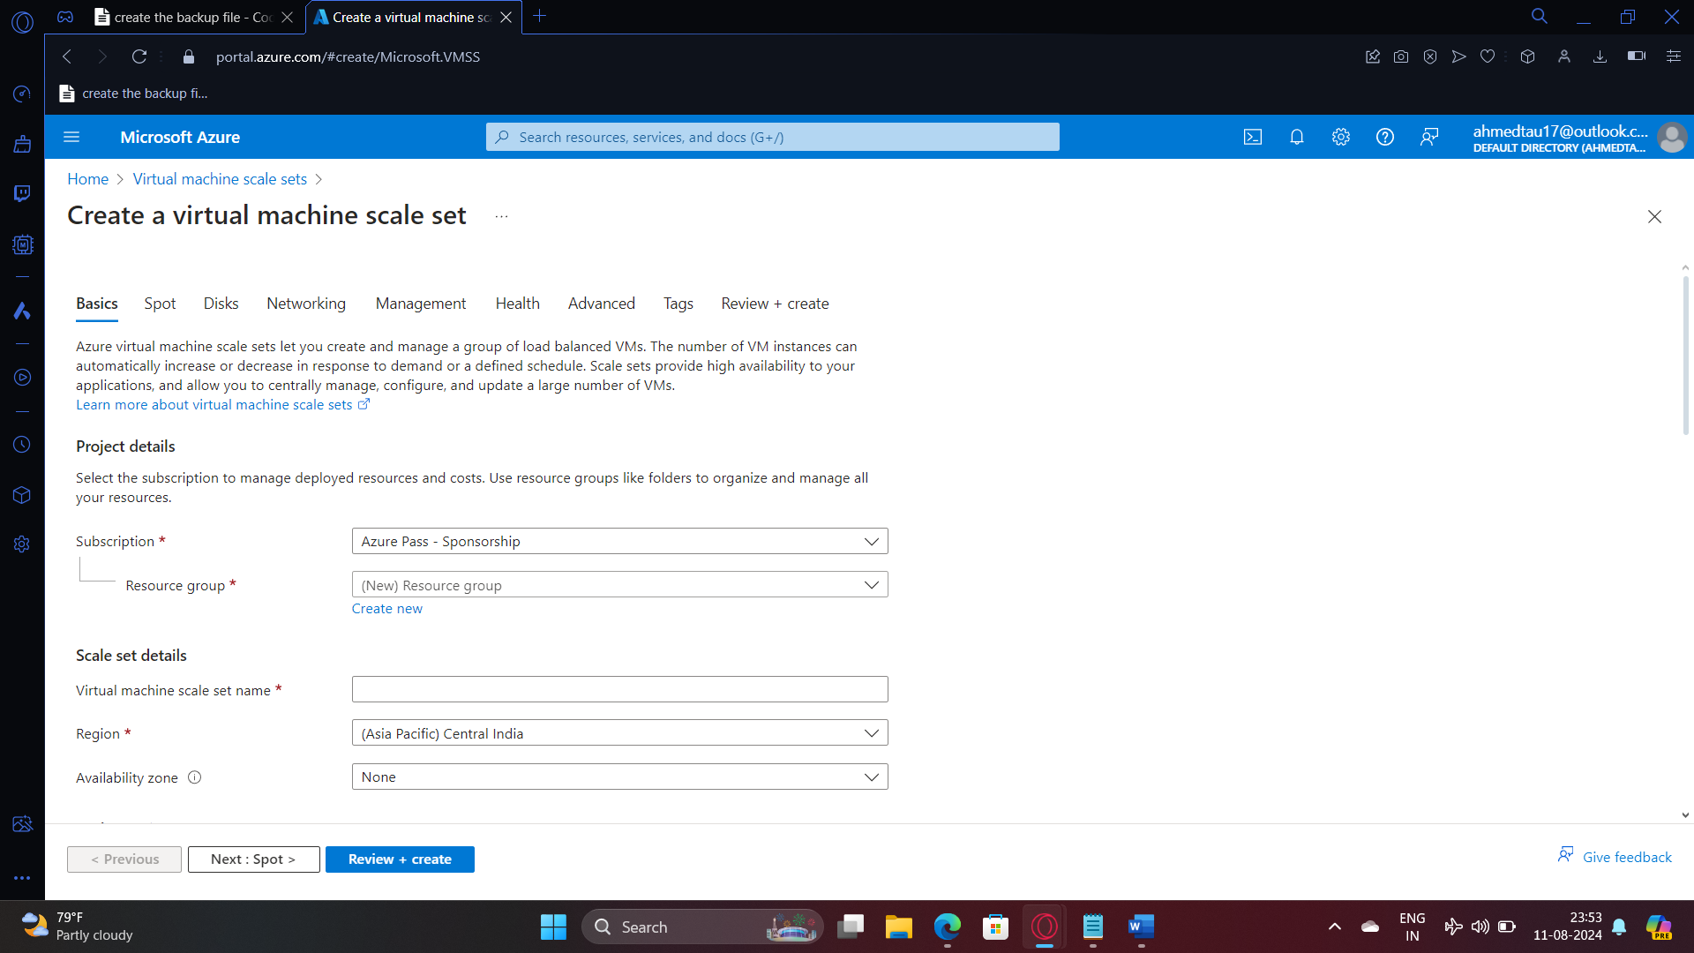

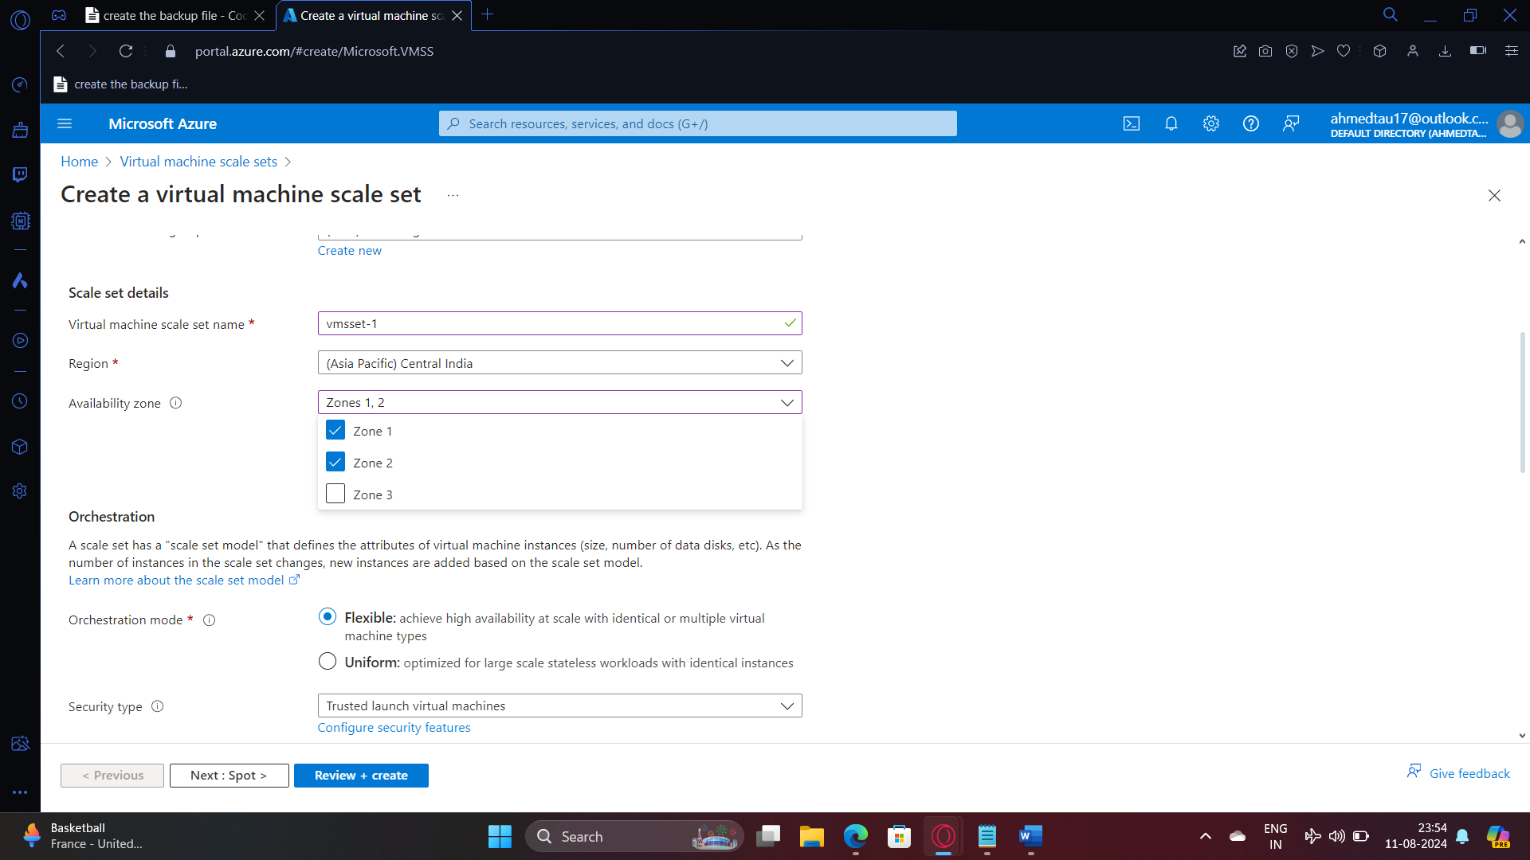

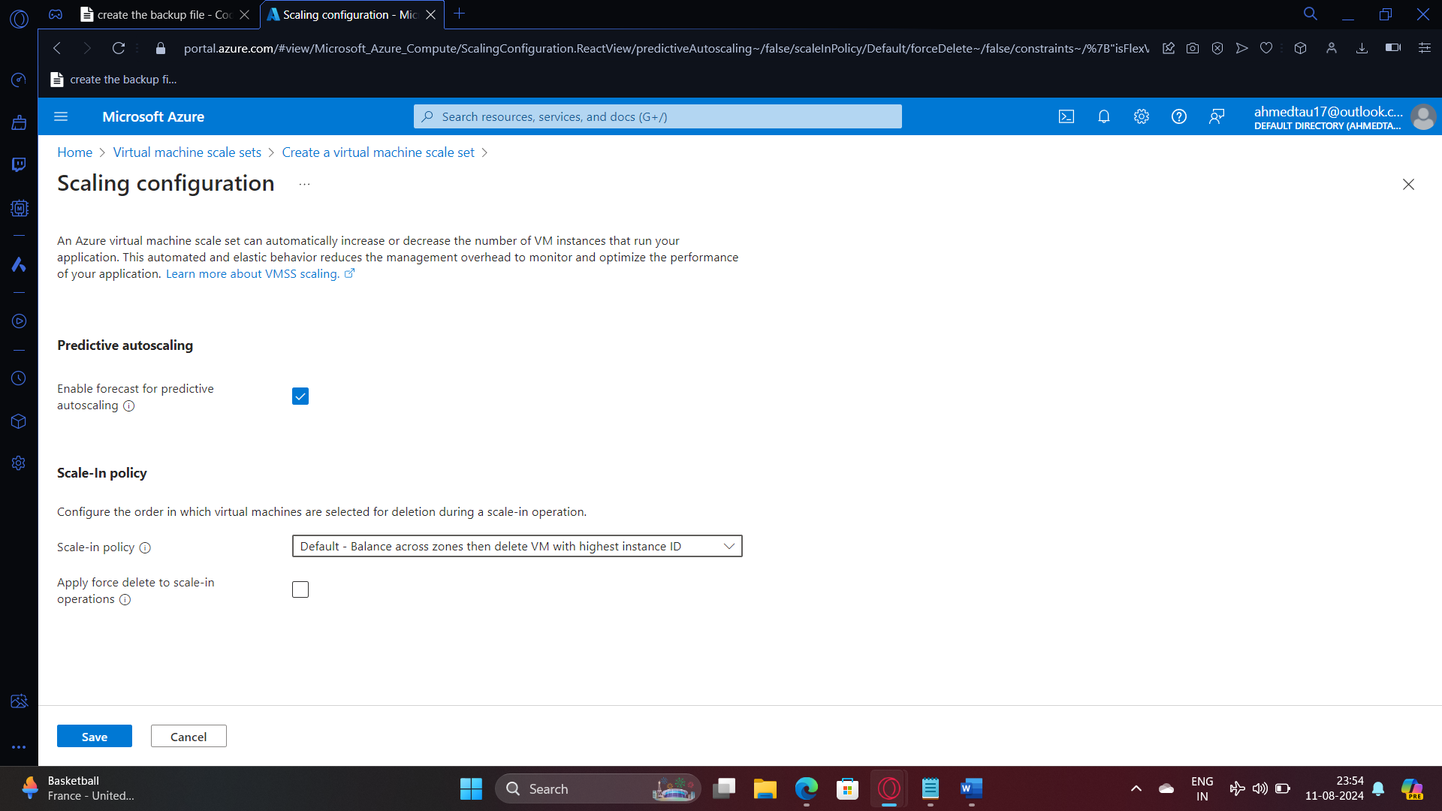

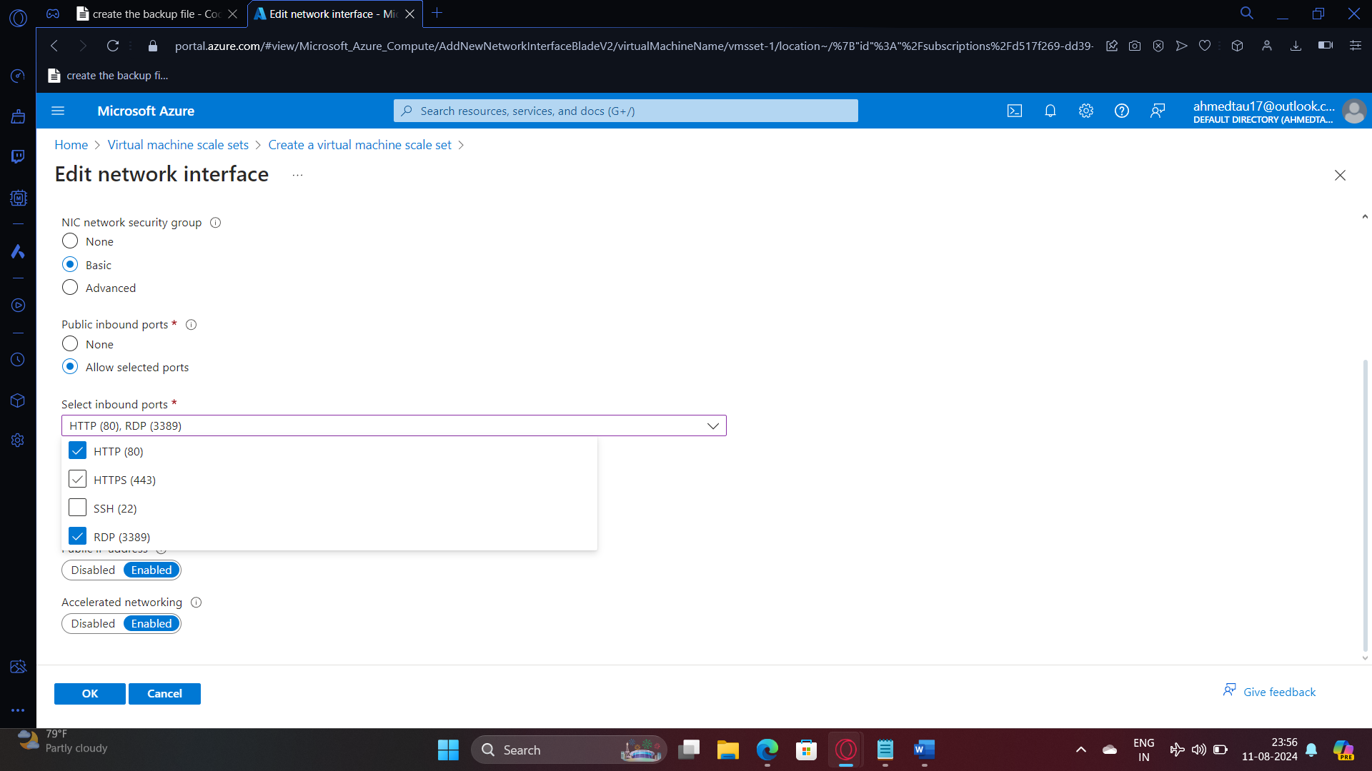

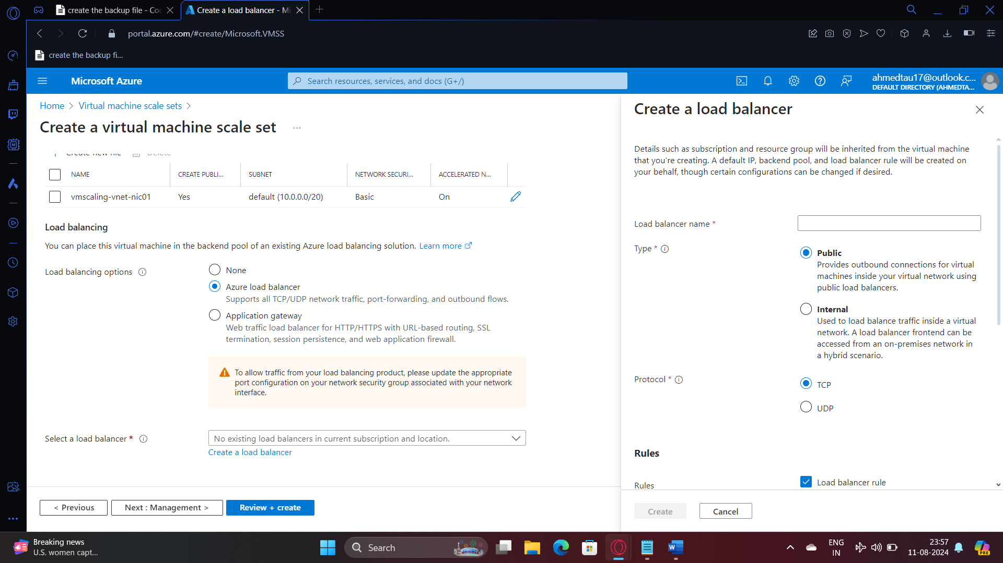

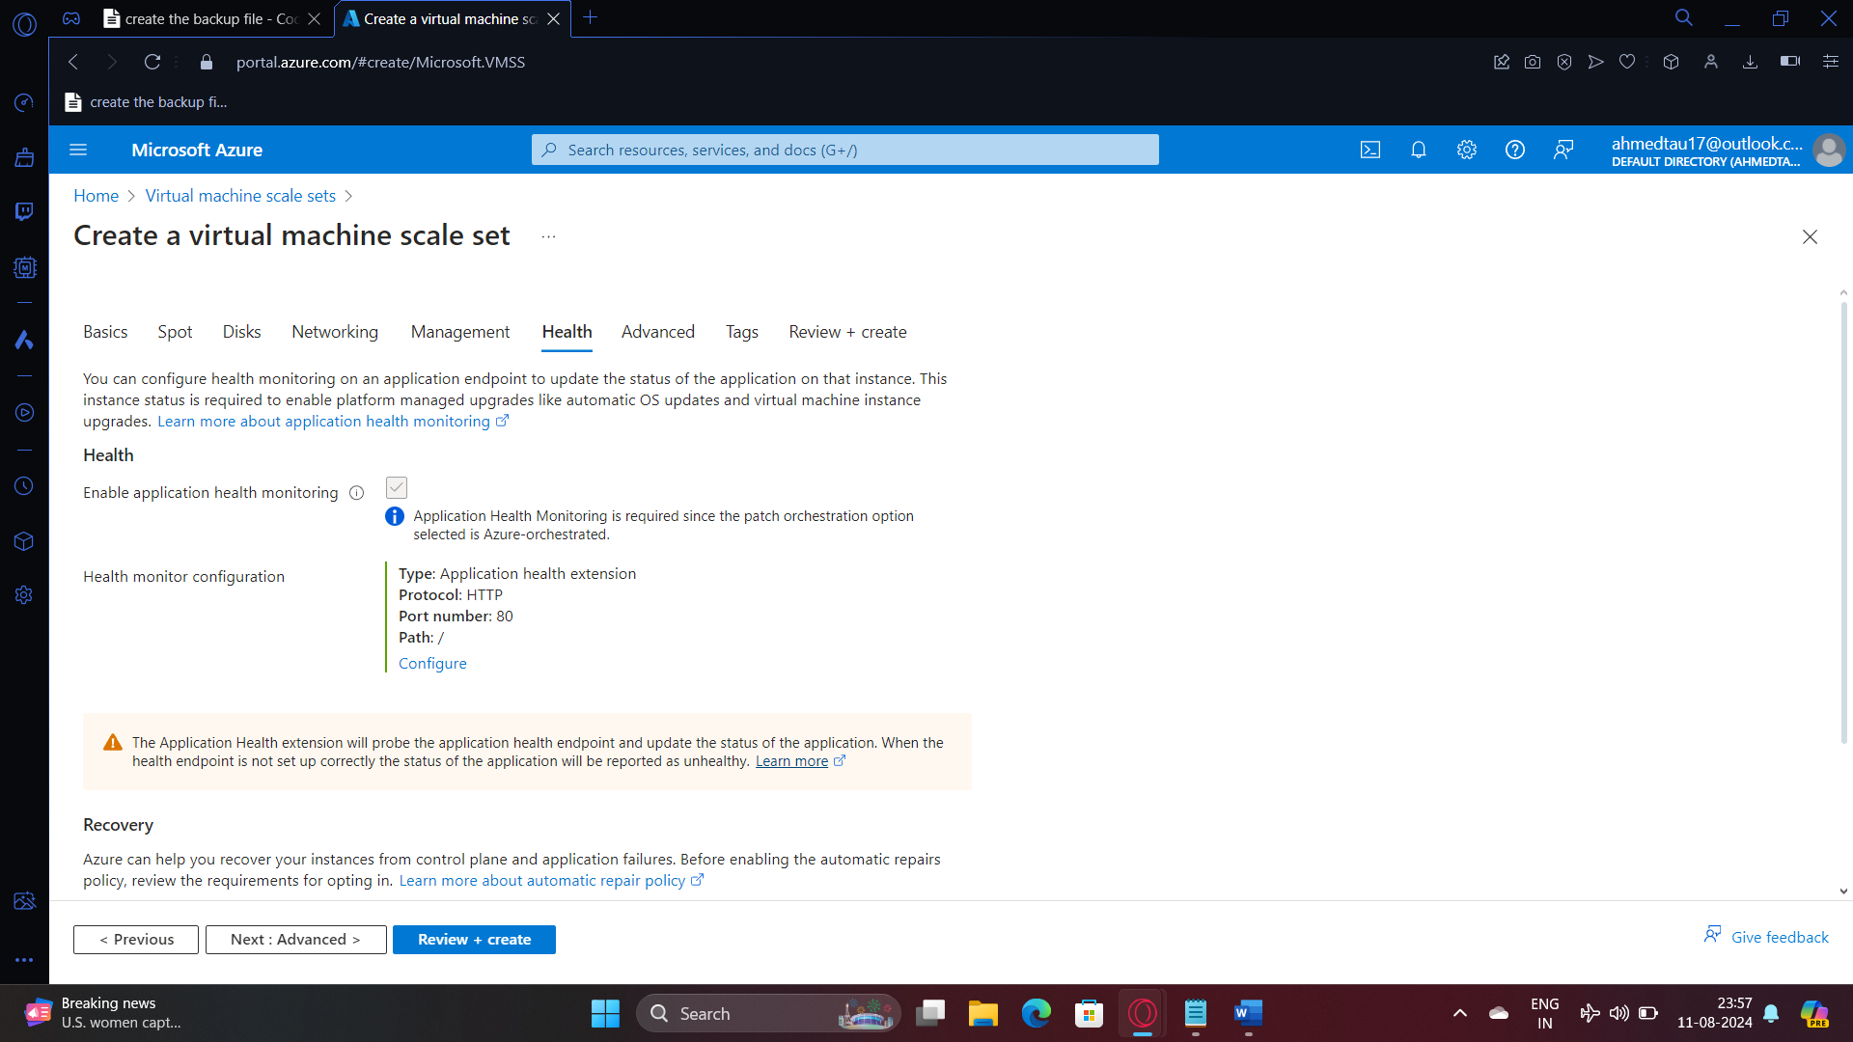

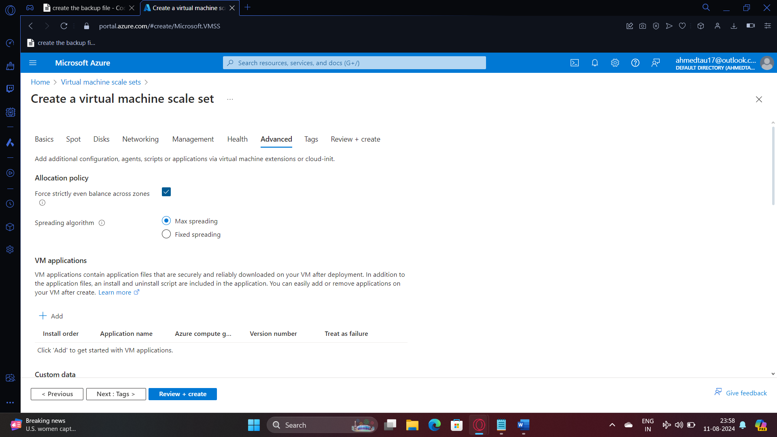

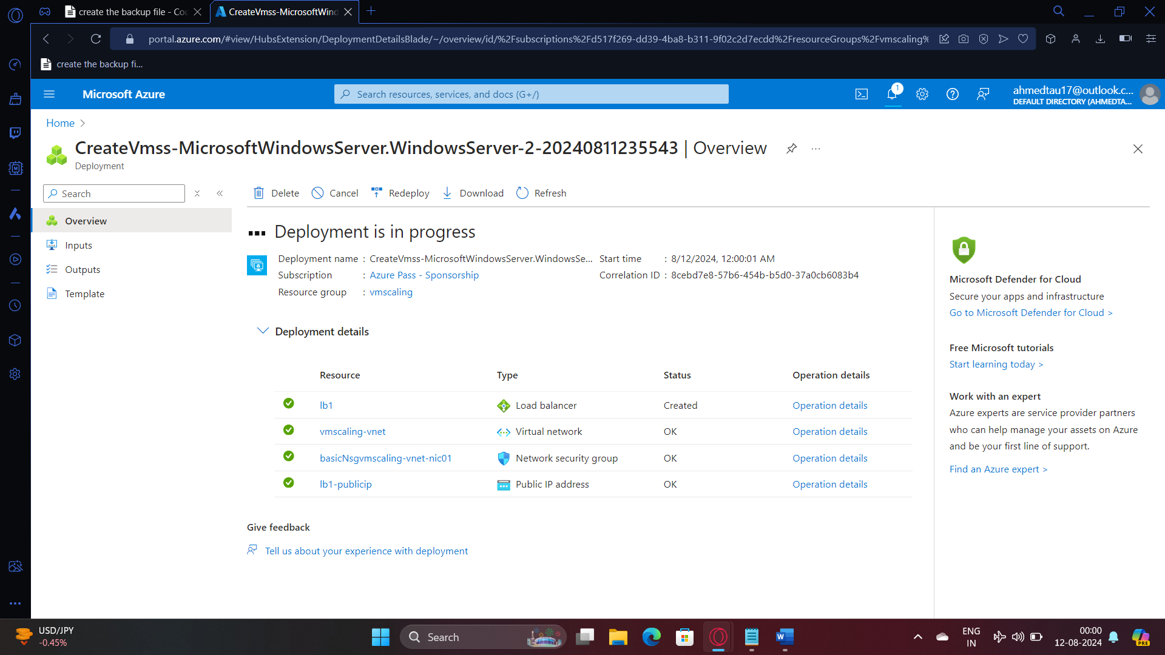

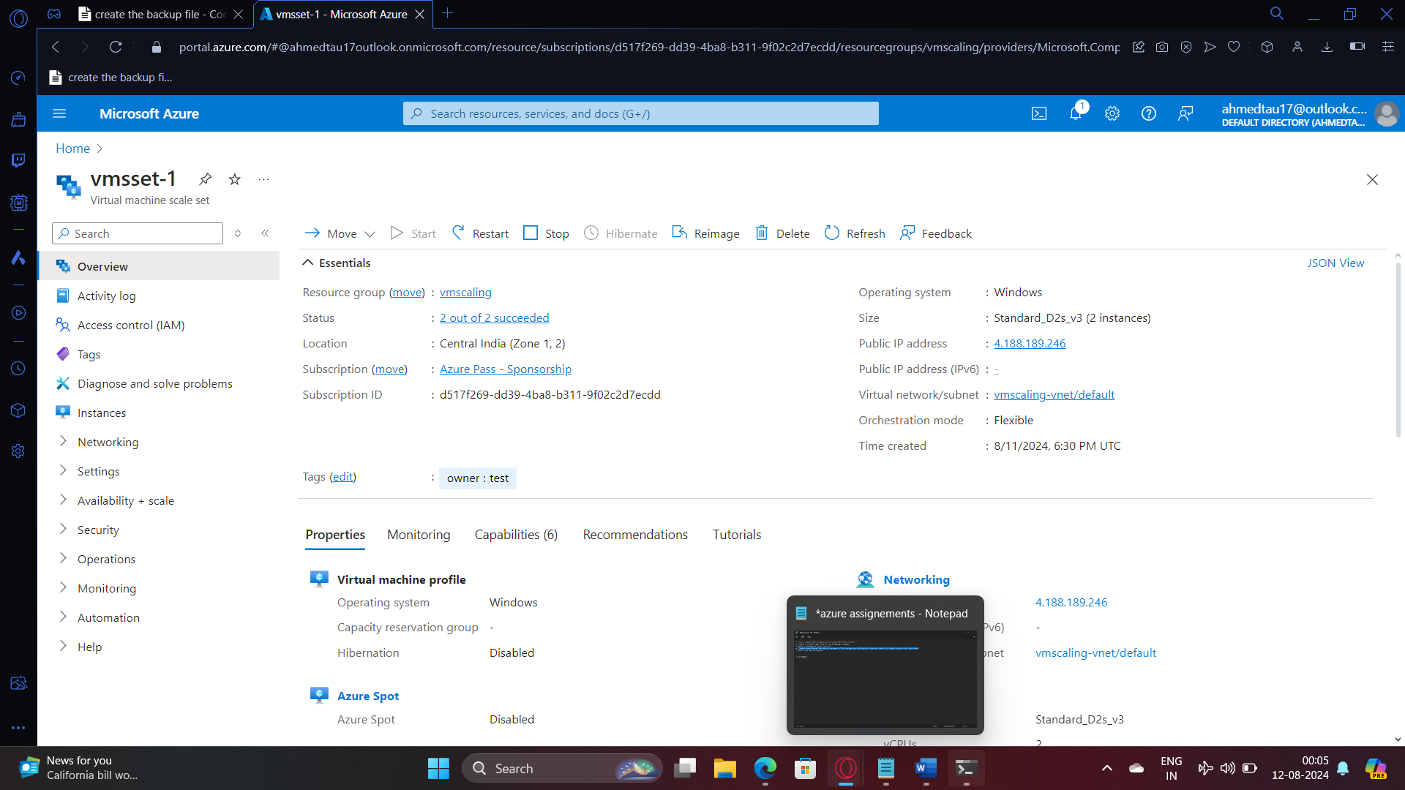

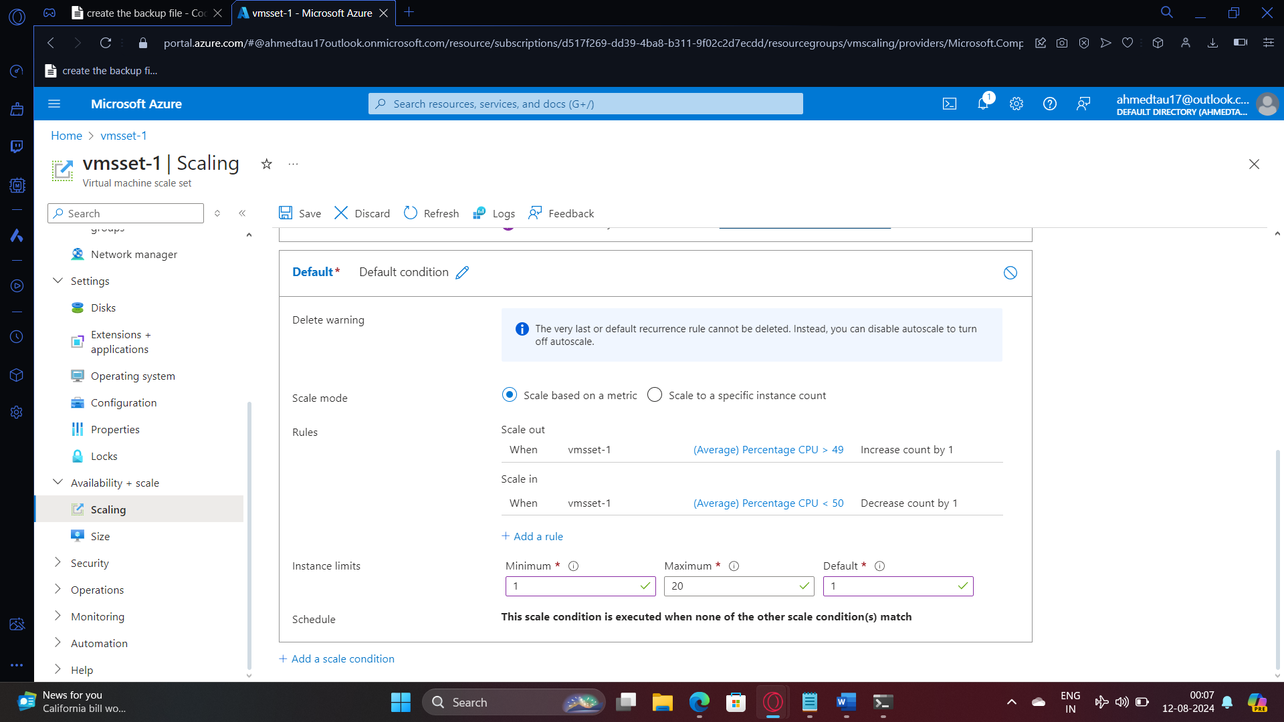

Before scaling up

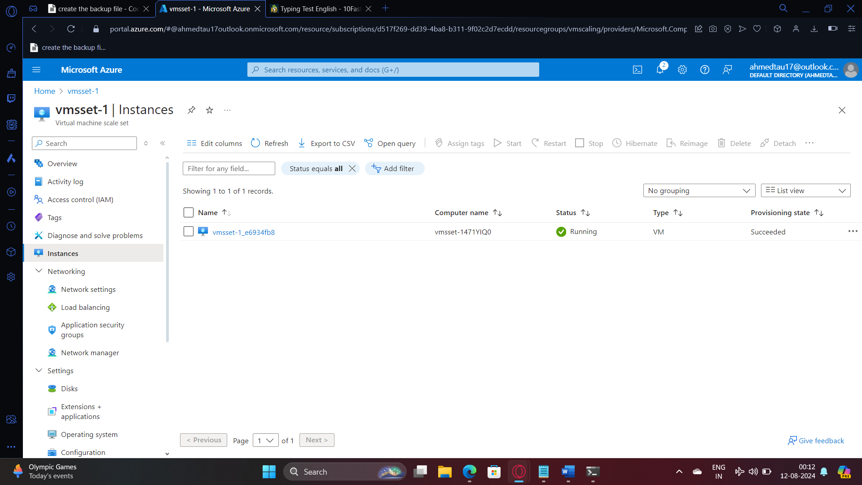

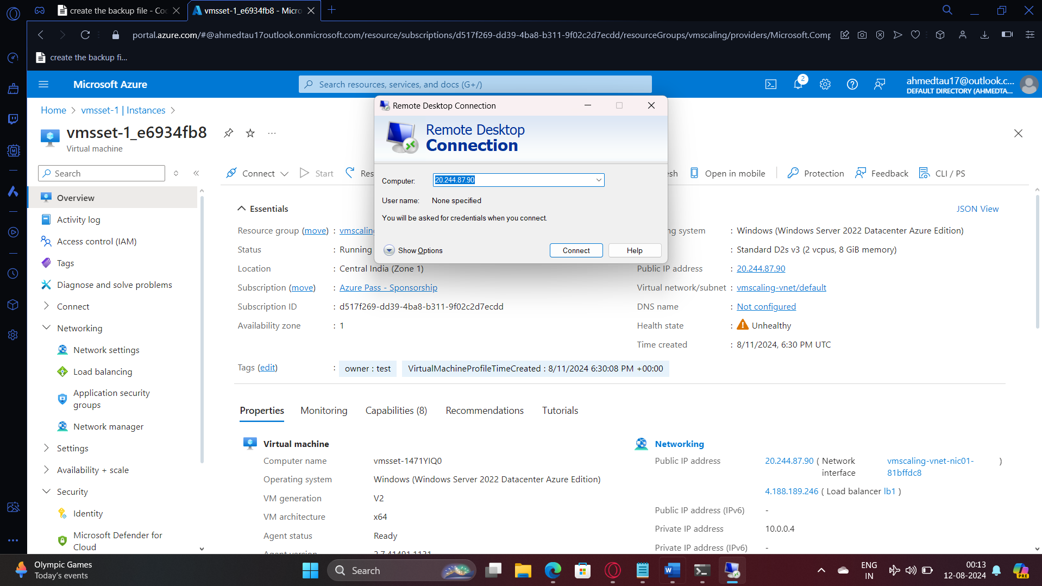

**Increasing the cpu stress by increasing the stress**

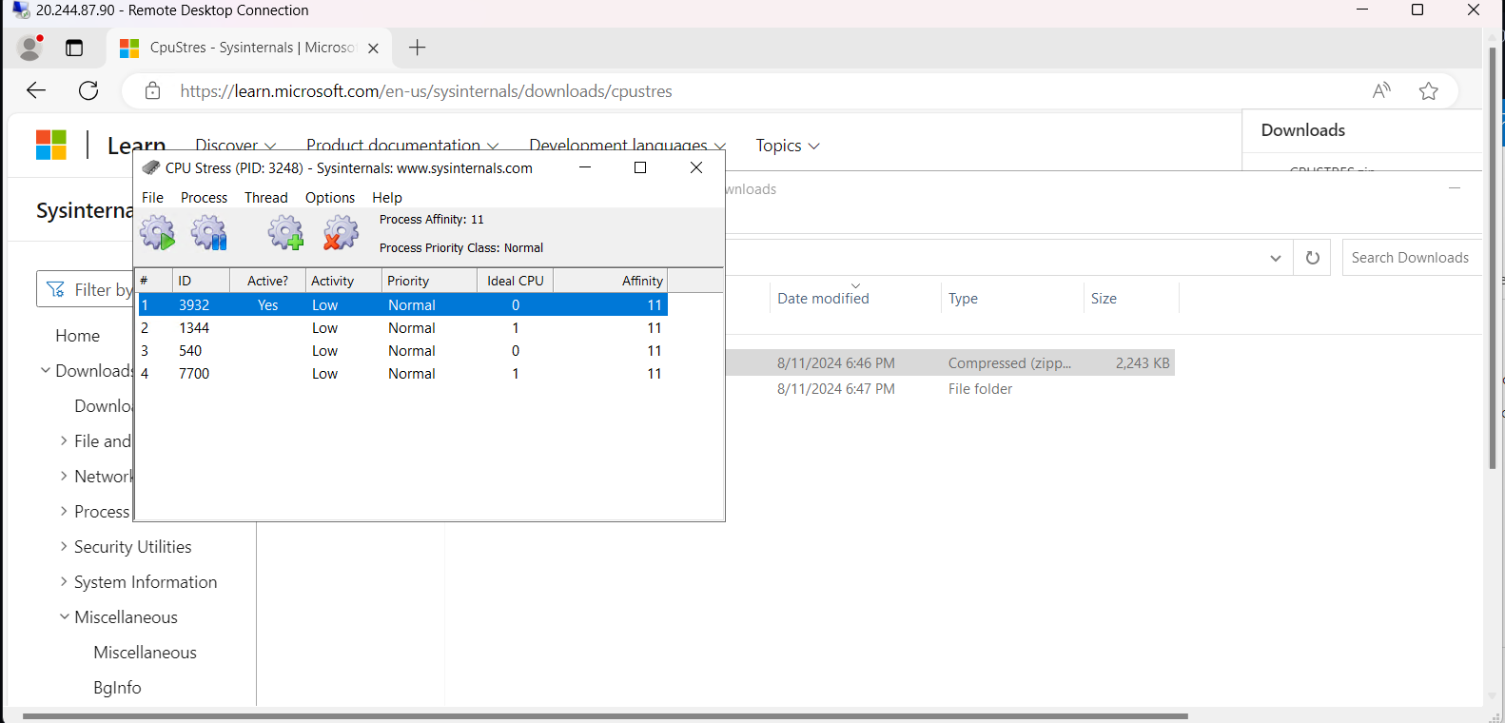

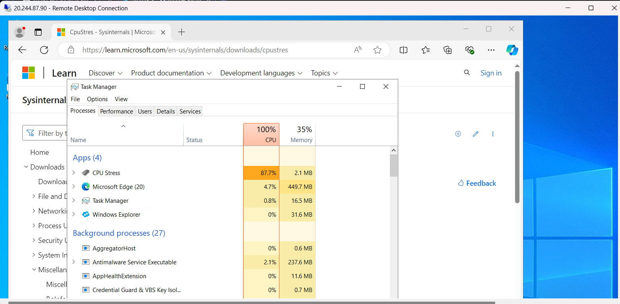

**Creating a new instance since the load increased**

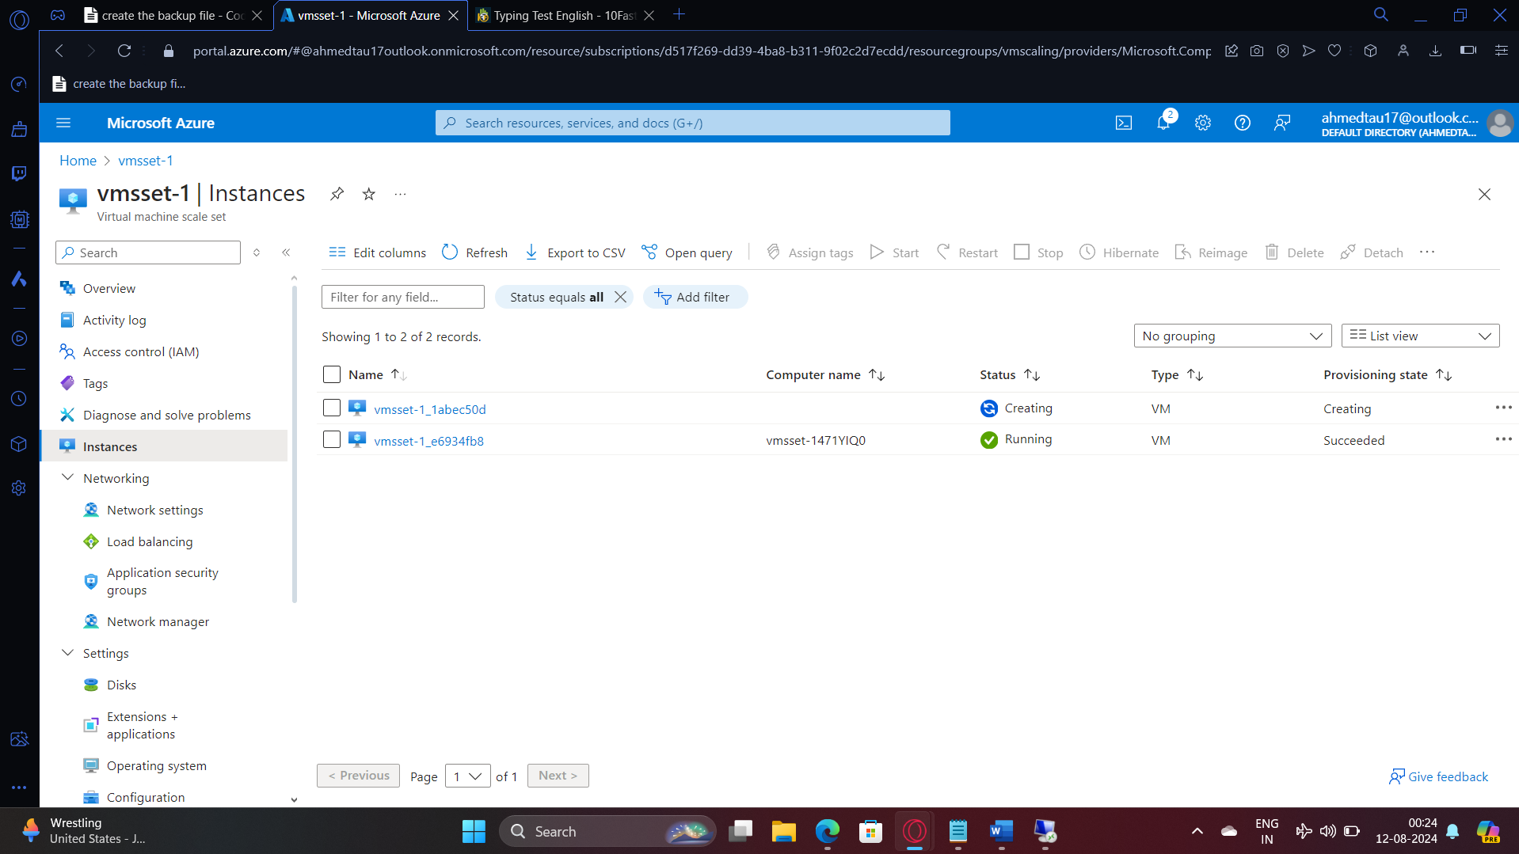

**Decreasing the cpu load to scale in**

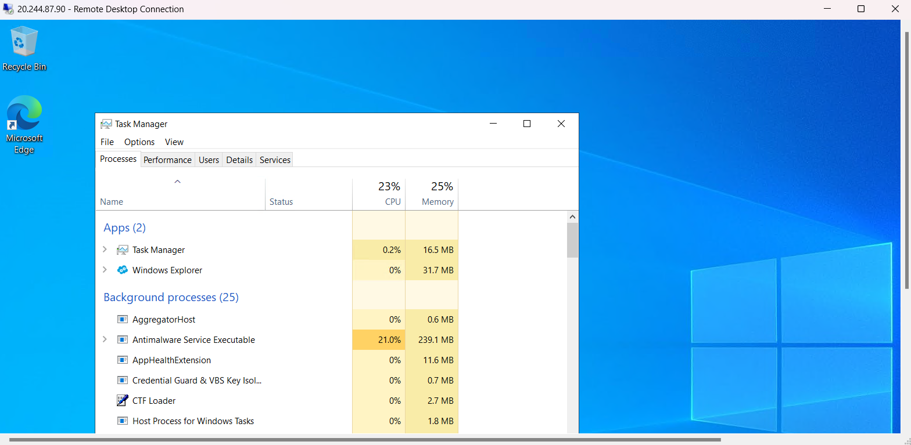

**After Scaling in**

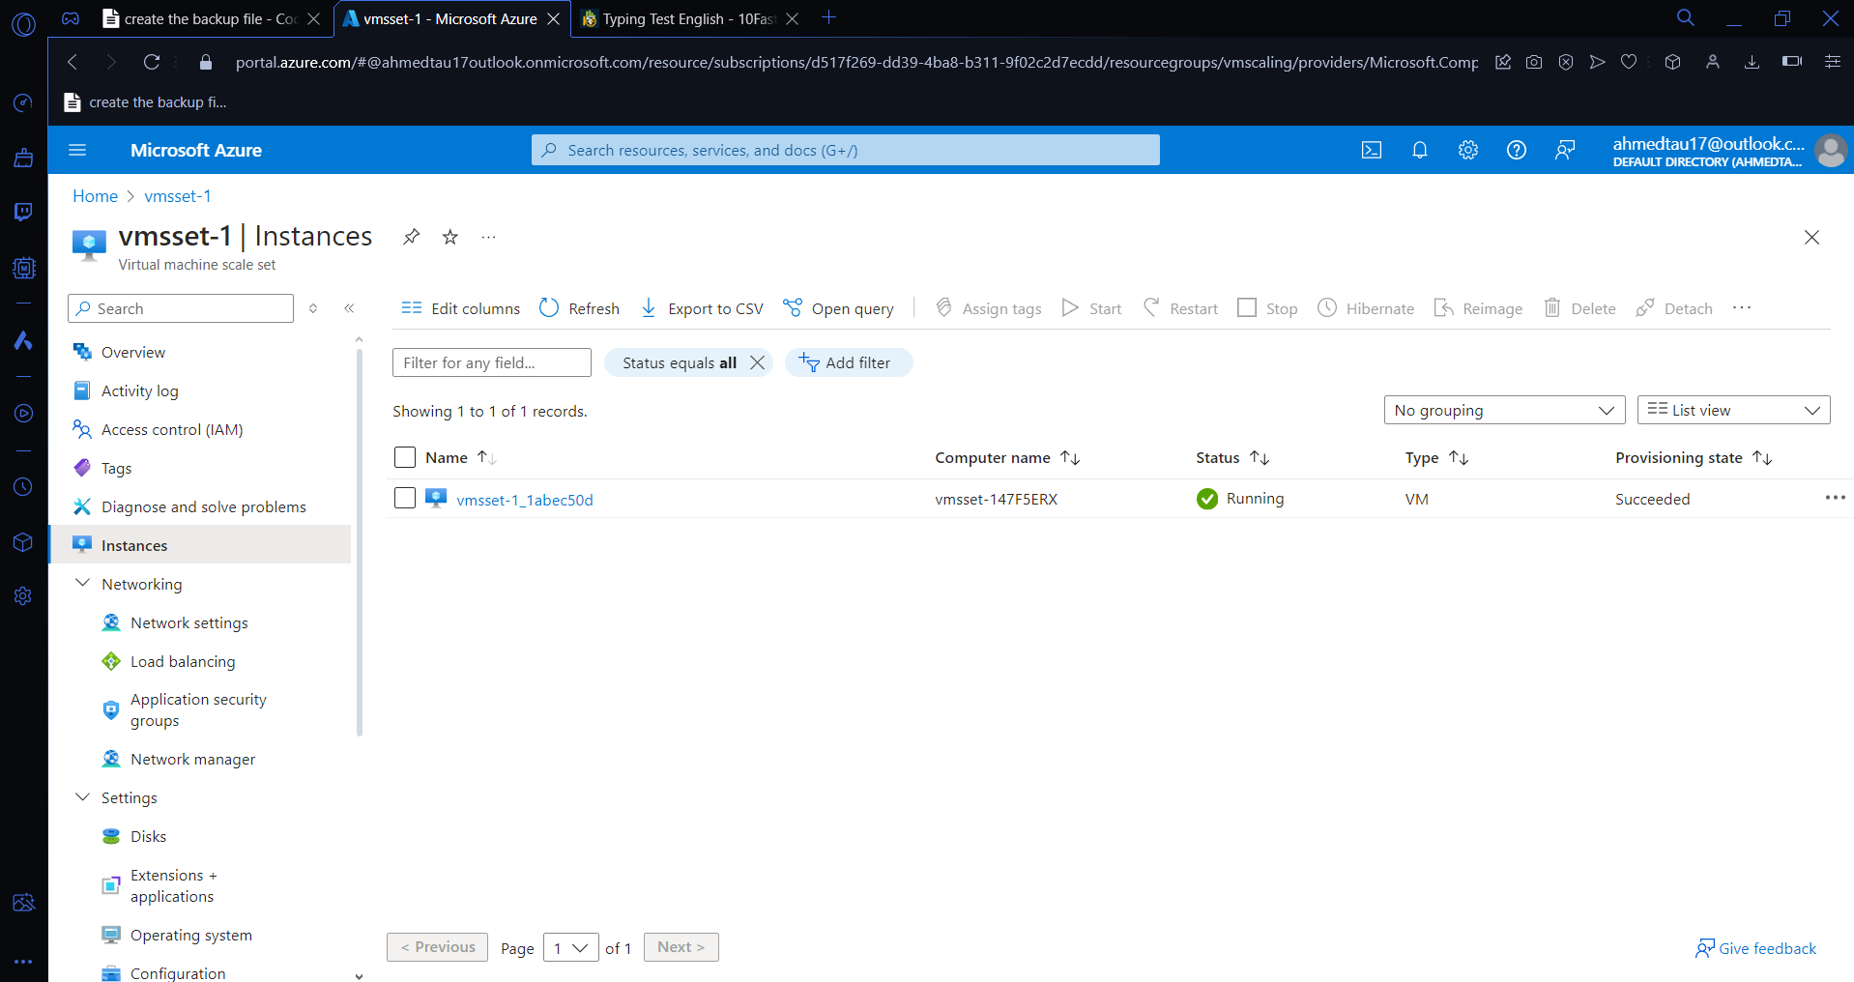

5. Host a web app spring pet clinic

A.

